Assignment 2. Install ansible and connect the nodes to master and execute the adhoc commands on ansible masternode vm and test the packages installed or not

Yum→yellow dog update manager

Epel→Extra package enterprise release

Here: Ansible Master Node: Public ip=3.112.239.34, Private ip=172.31.36.6 Ansible Node: Public ip=54.199.147.89, Private ip=172.31.42.222

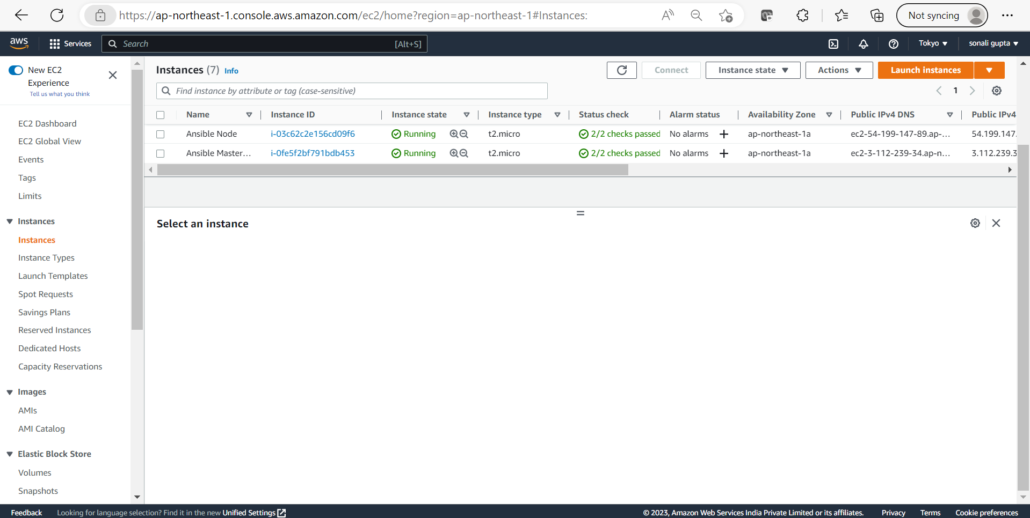

Ansible master node connect

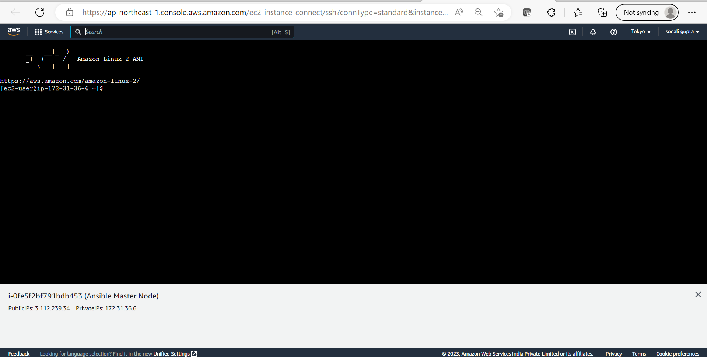

sudo amazon-linux-extras install epel

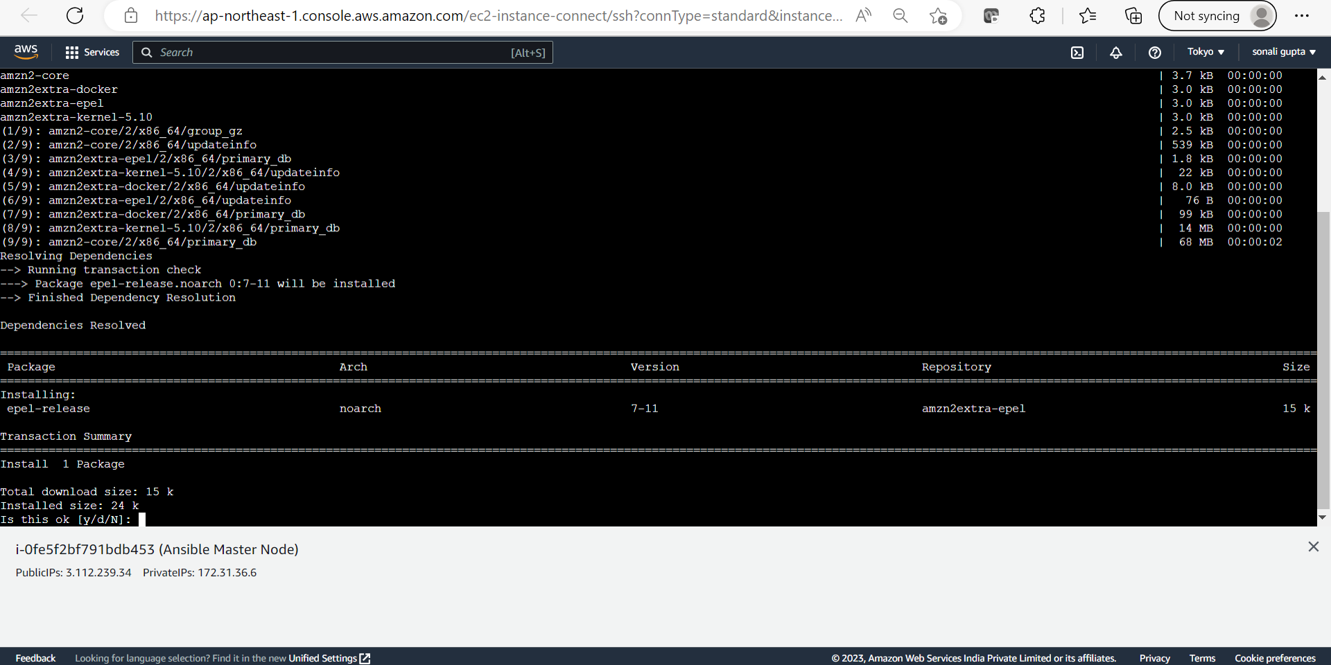

sudo yum install ansible -y

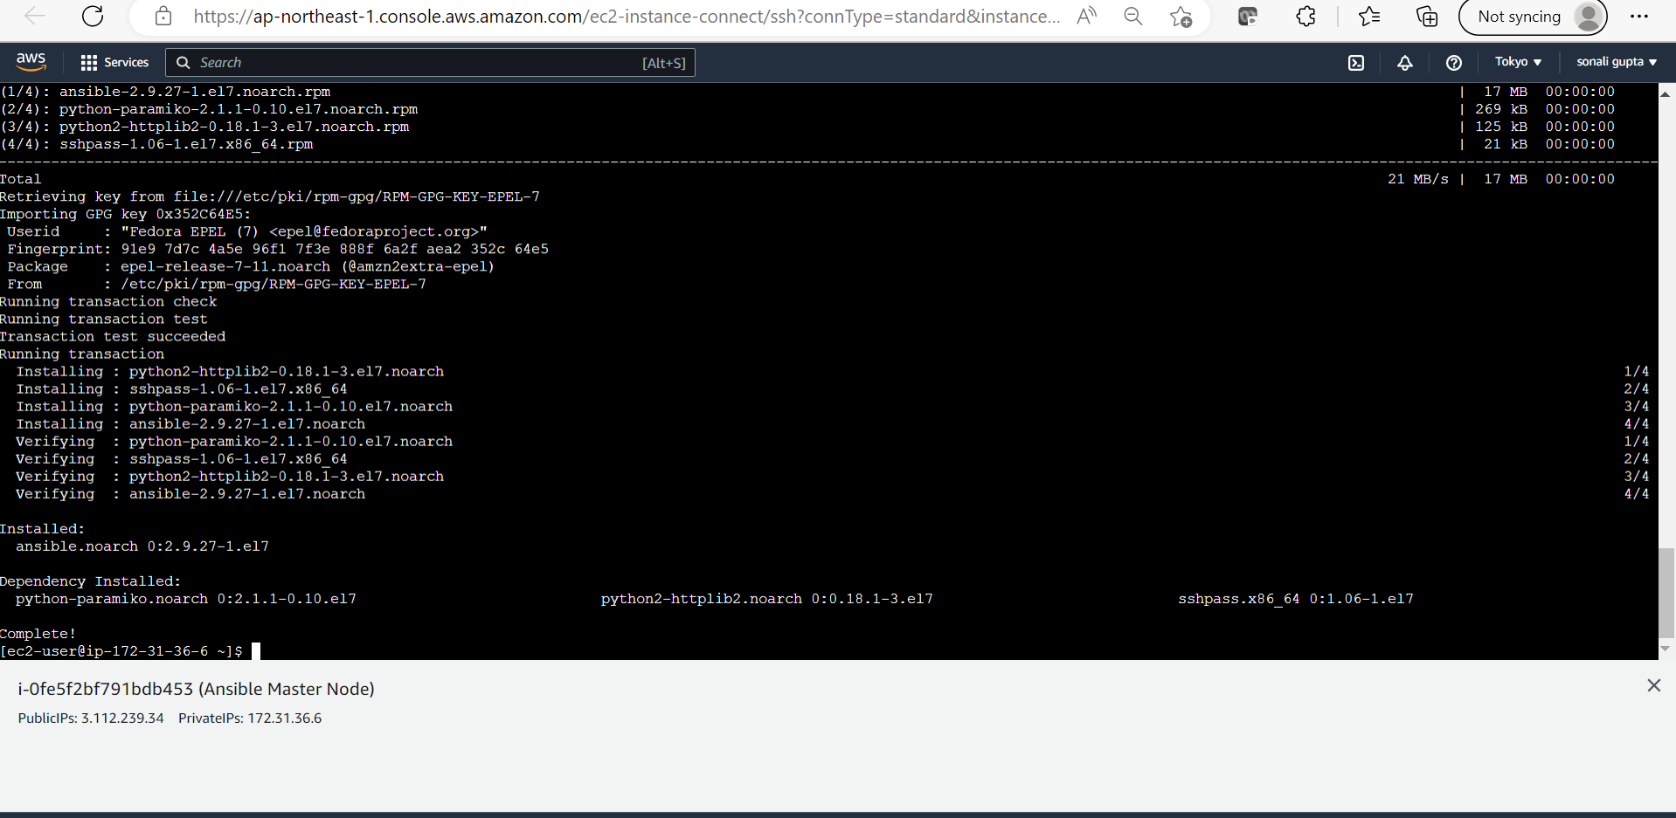

Ansible installed Checking version

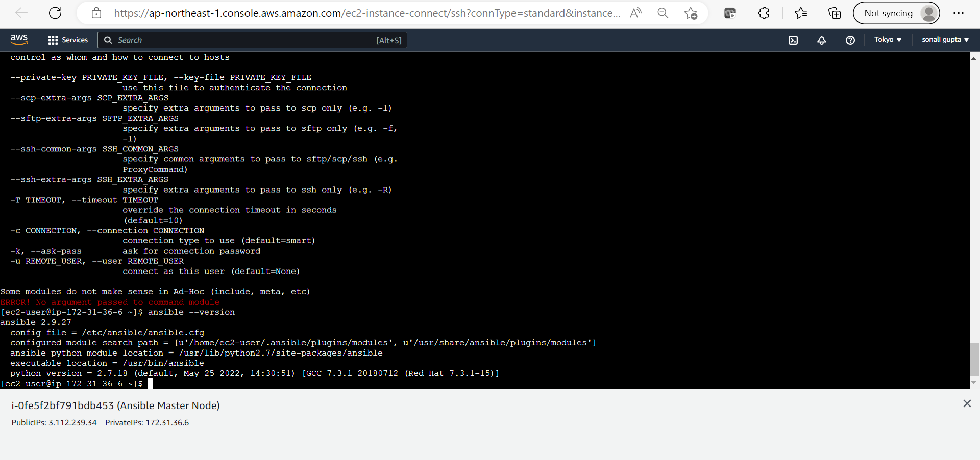

Installing Python:

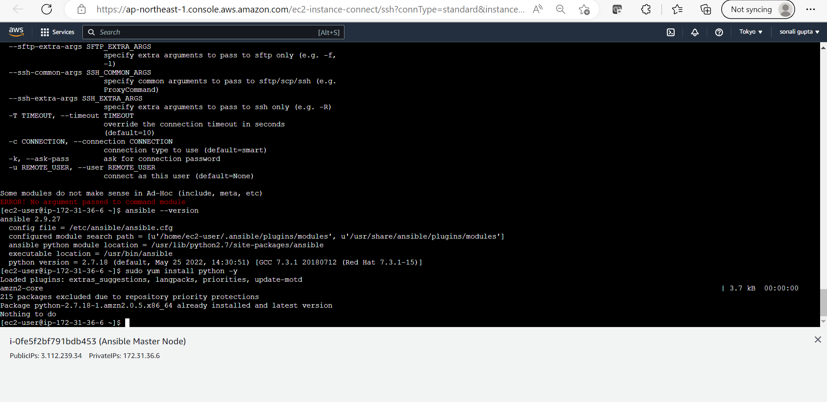

Installing Openssl:

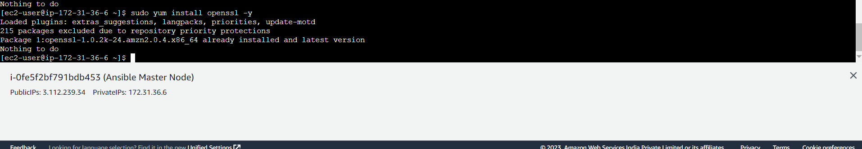

installing Docker:

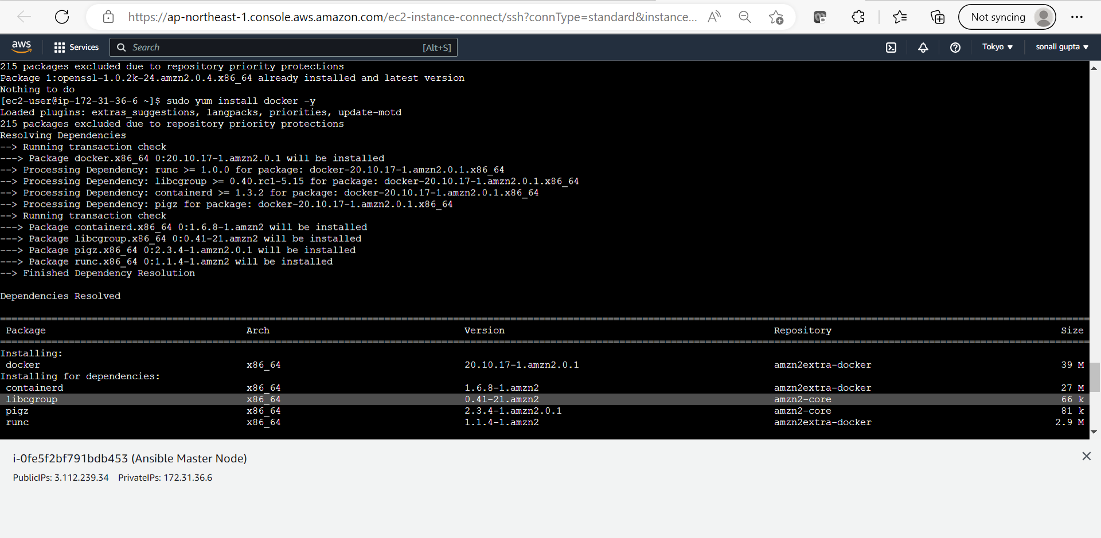

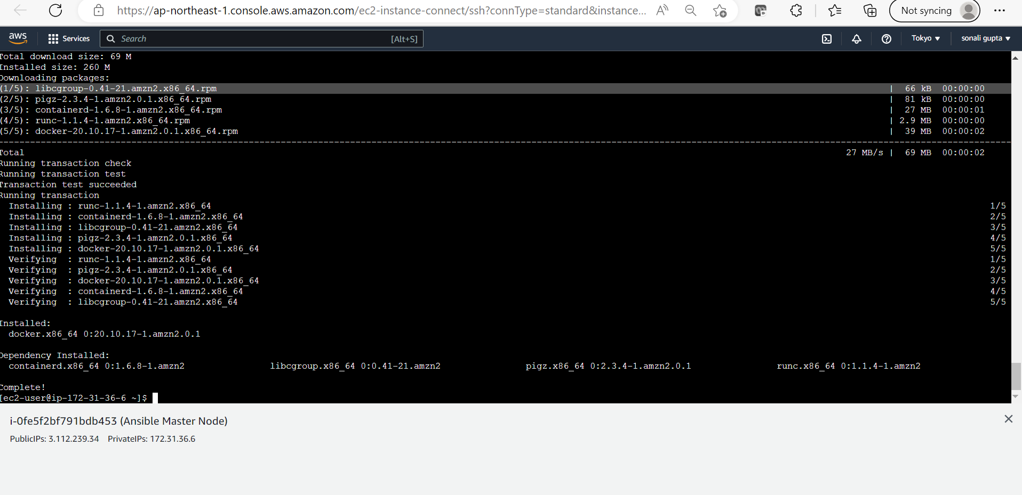

Docker version:

Ansible version

NOW IN NODE

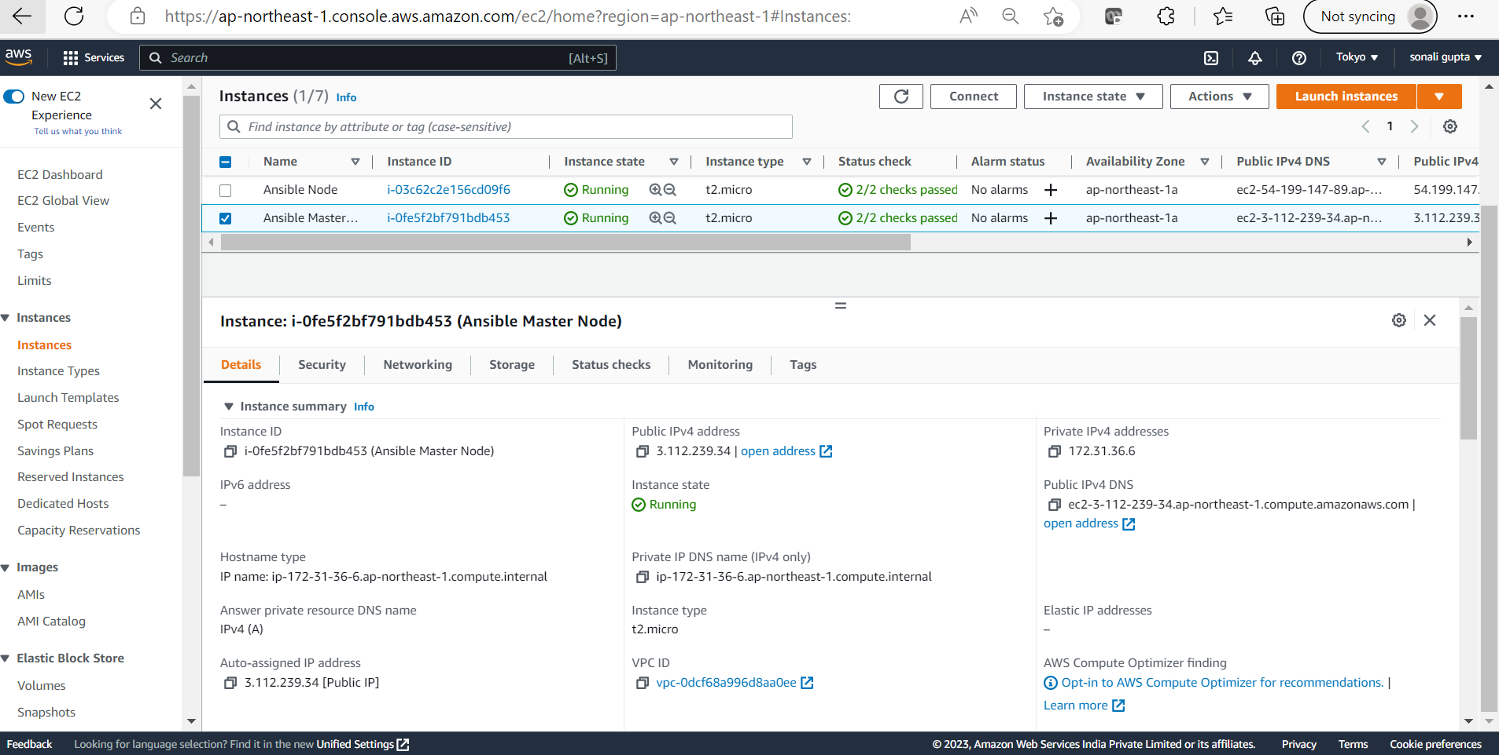

Node

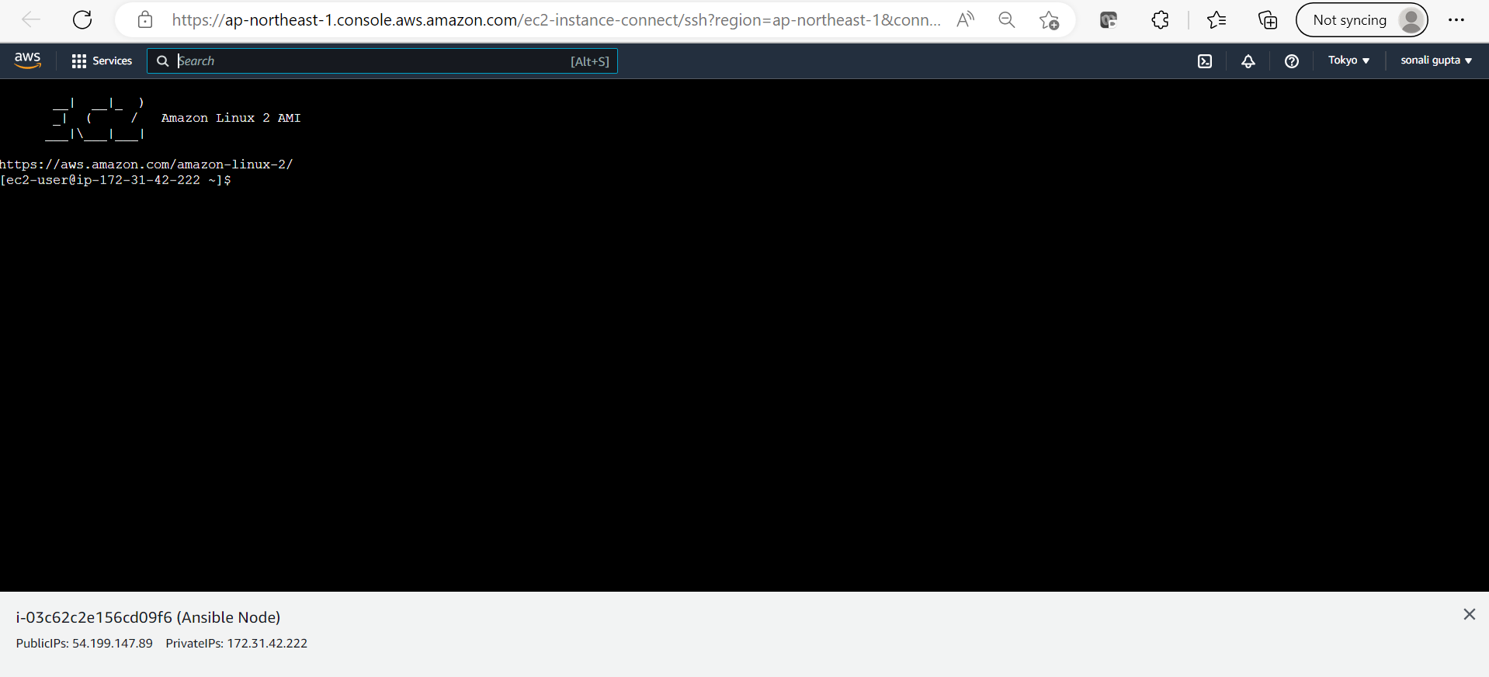

To genrate Now Genrate Key:

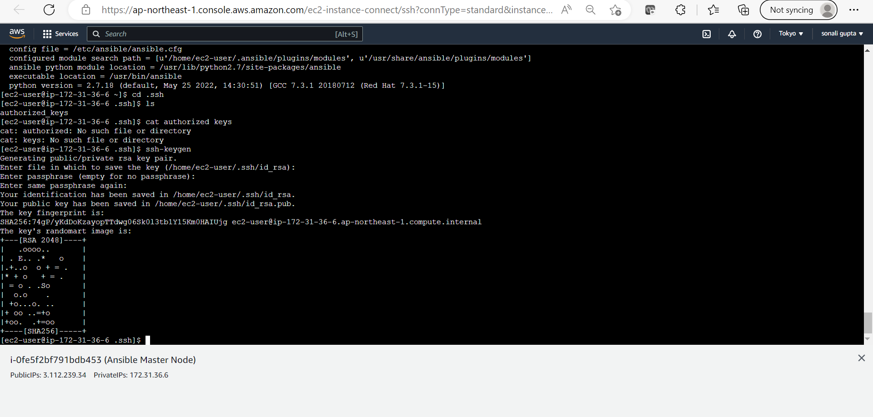

Check the number of keys available

Now from child Node side: Same

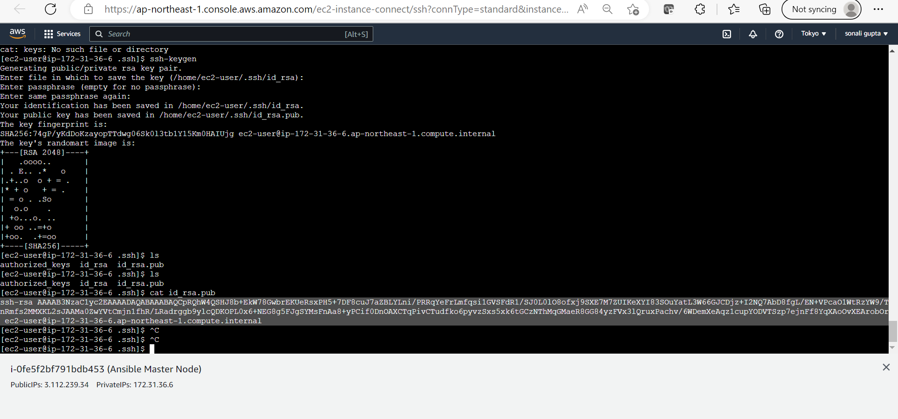

Now From Node: AWS Connect

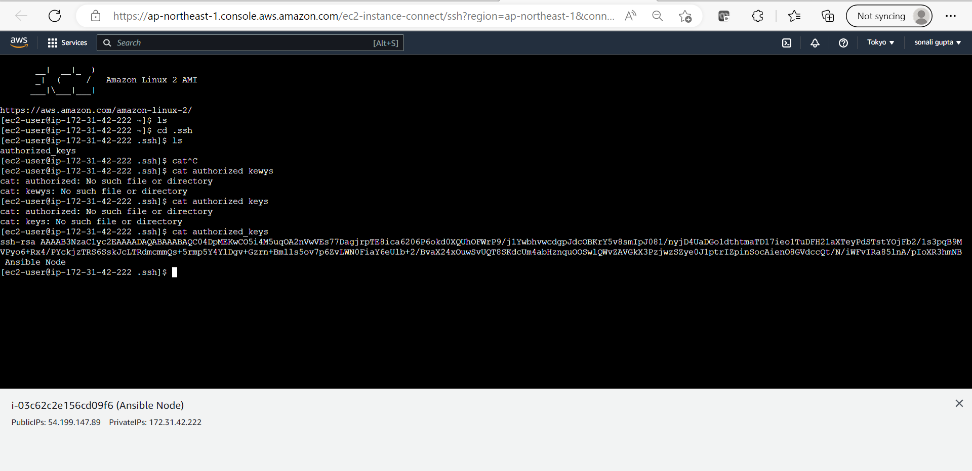

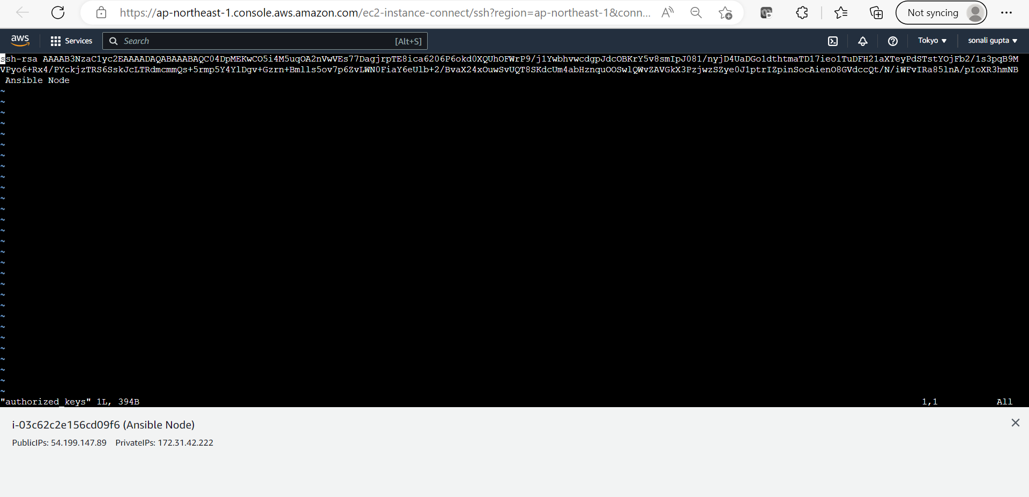

Press insert key for insert mode

Now Paste Public Key from notepad of the Master Node: And press Esc+:+wq+Enter → To Save

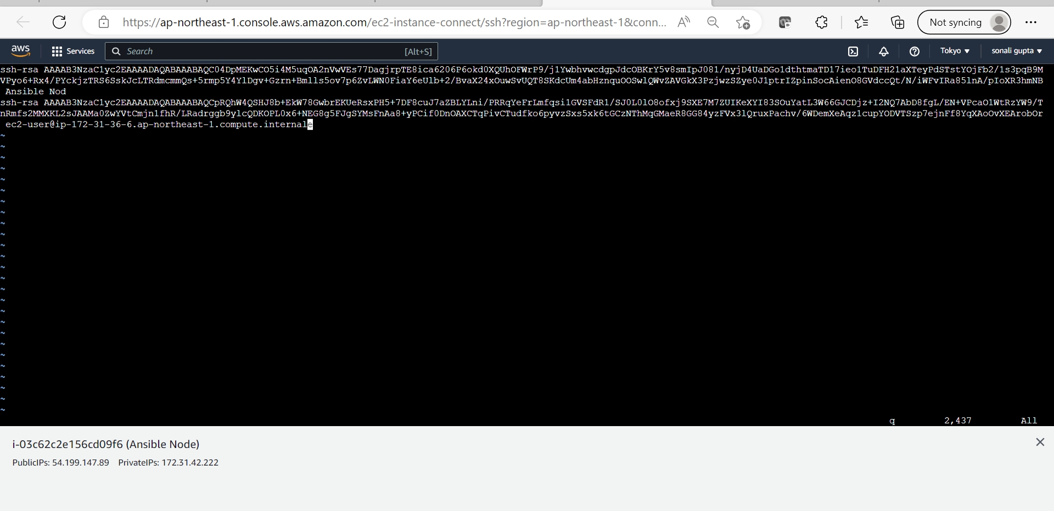

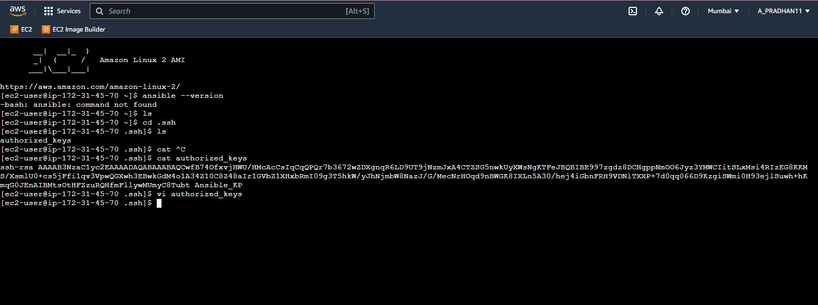

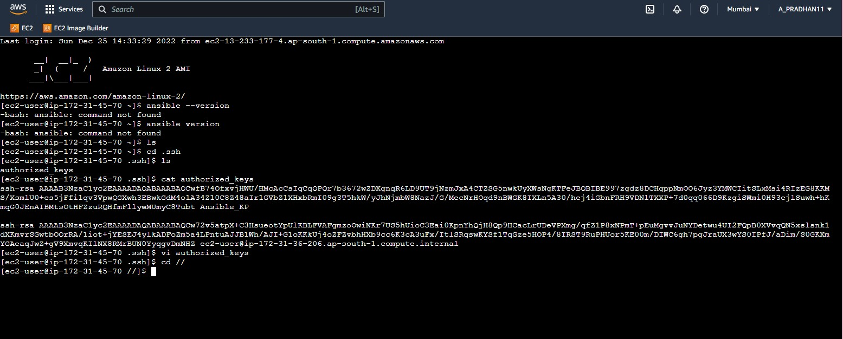

### From Master Node

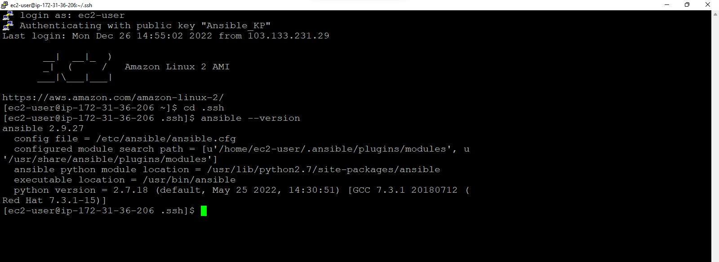

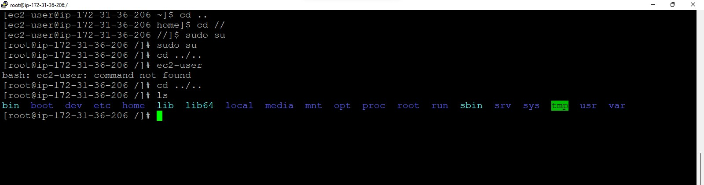

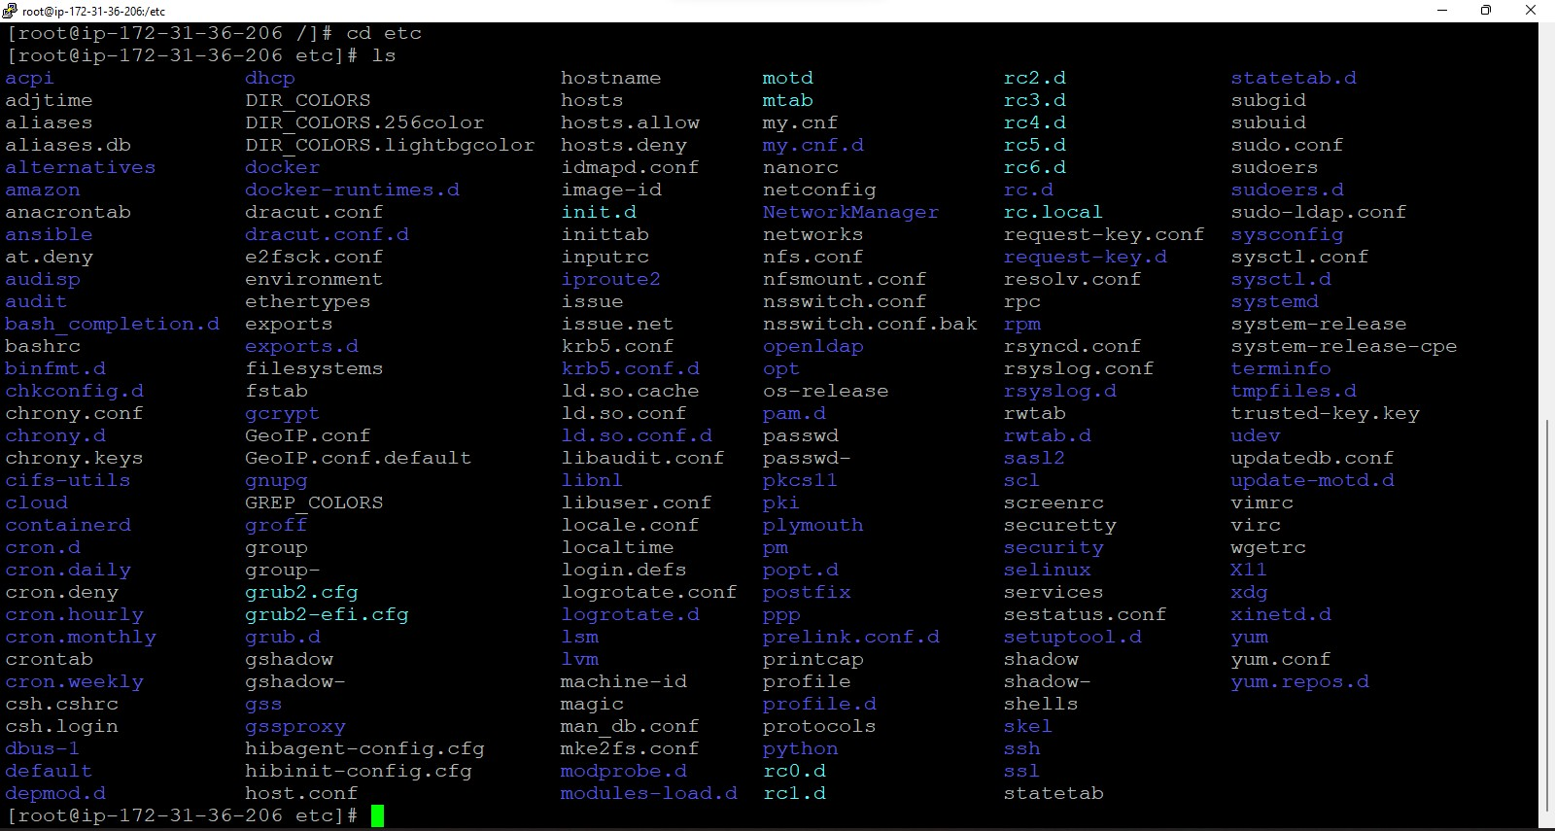

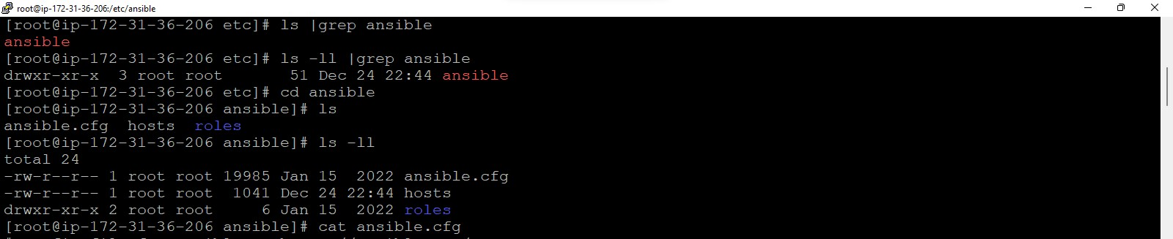

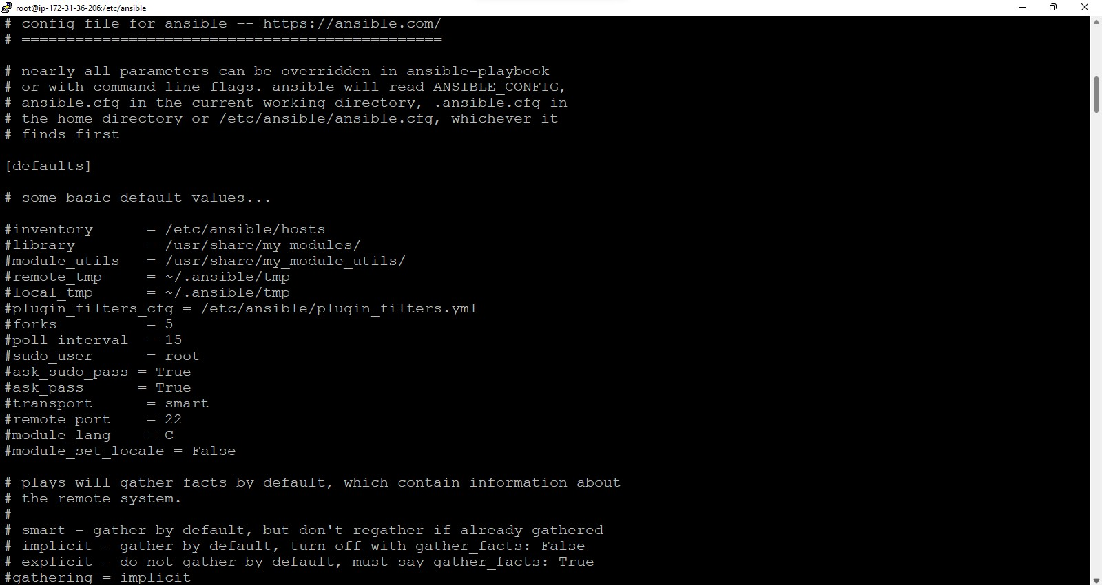

Opening Host file of Master Node

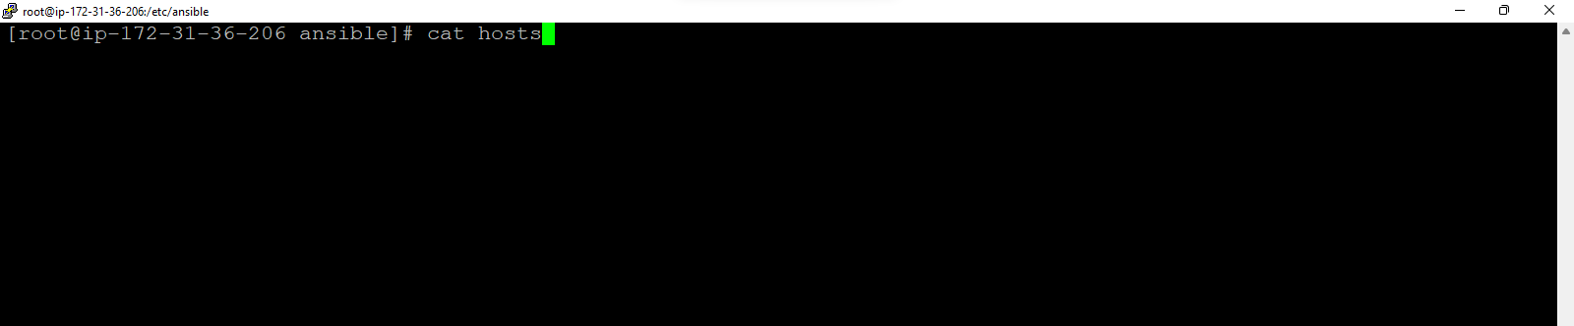

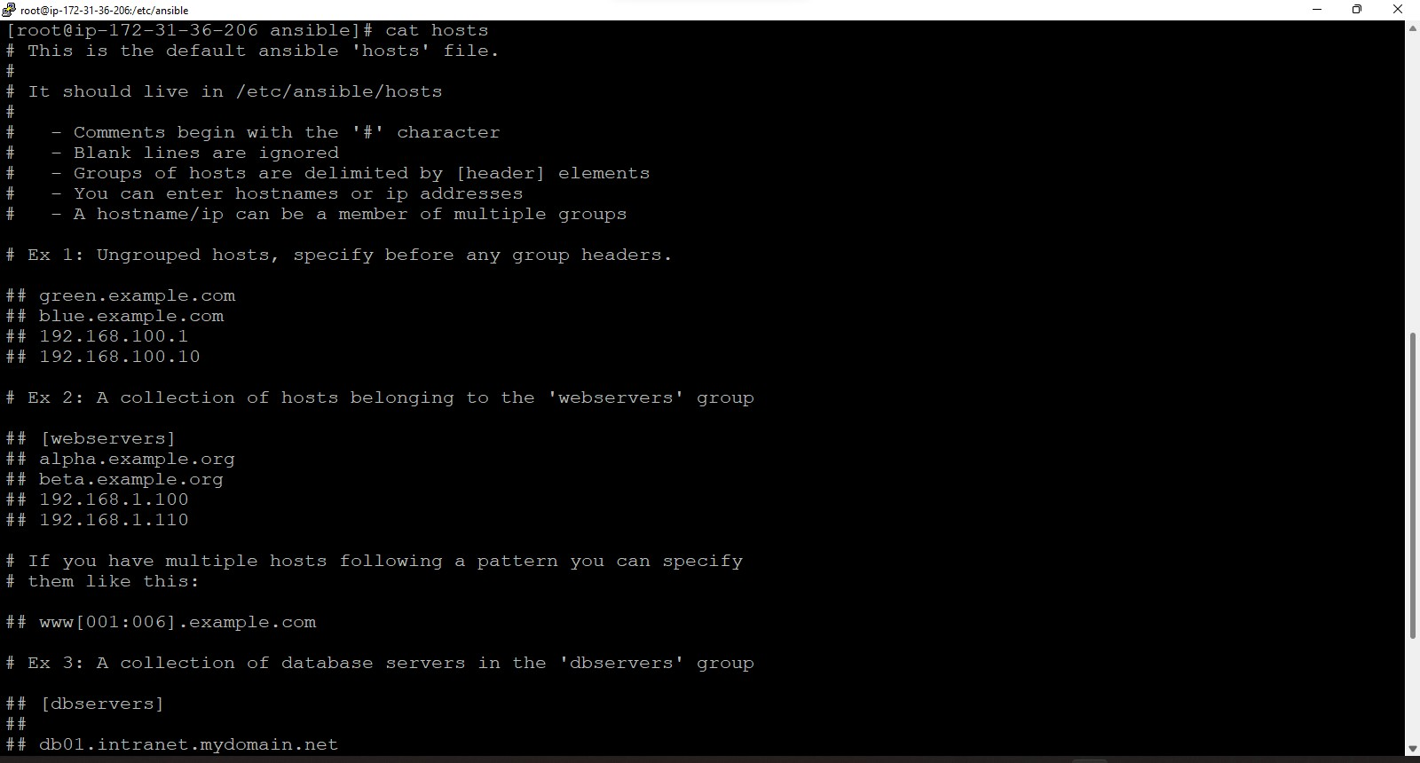

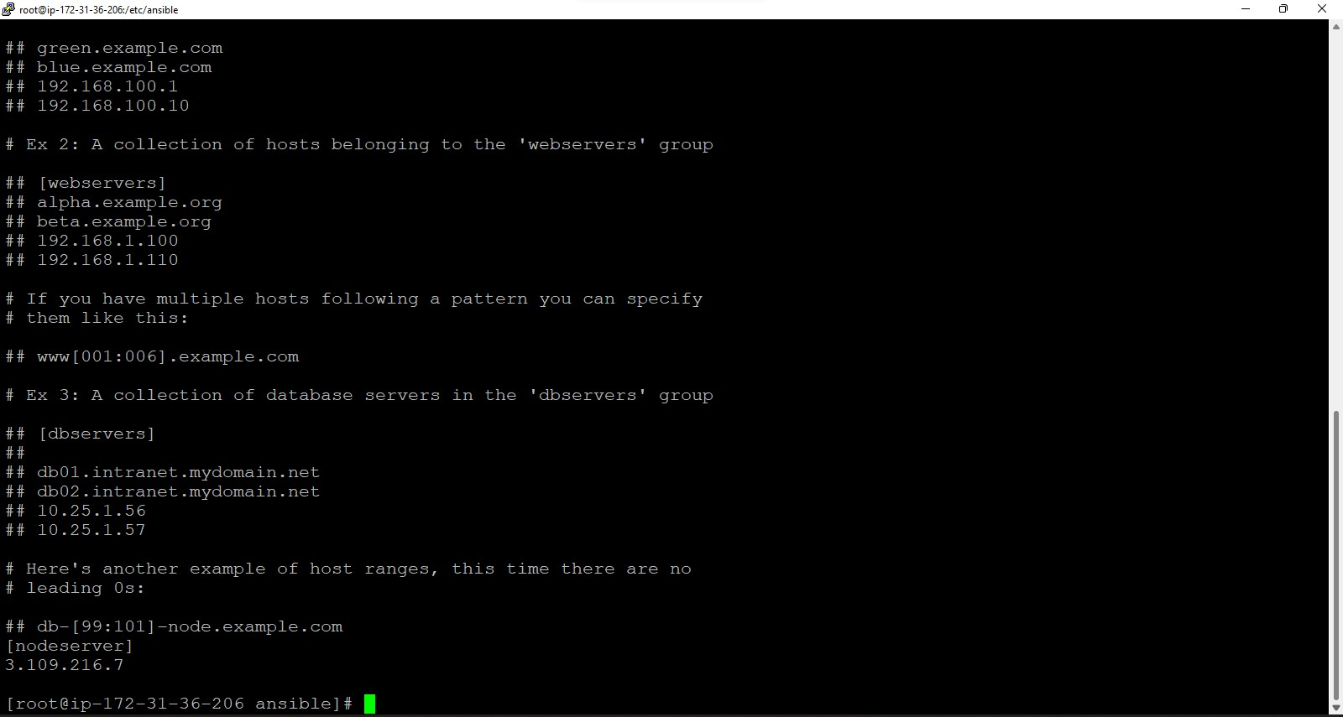

### Now checking the ip of Node running on Master

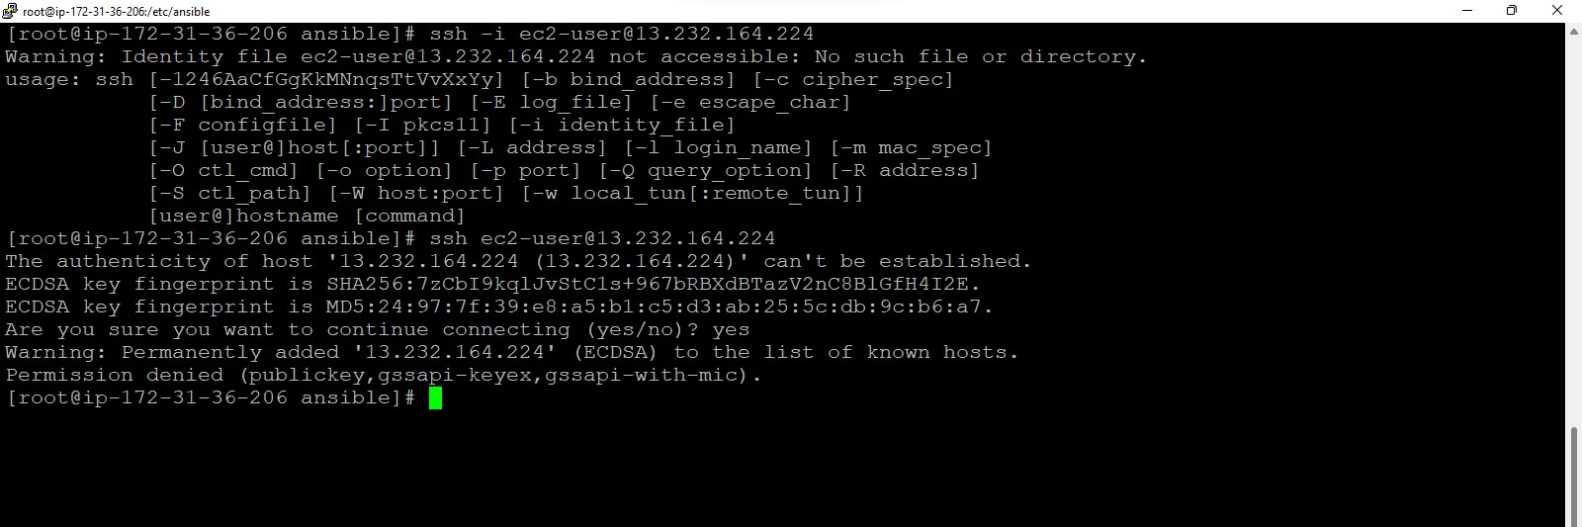

Its permission denied.

### Thus,

Now open vi hosts

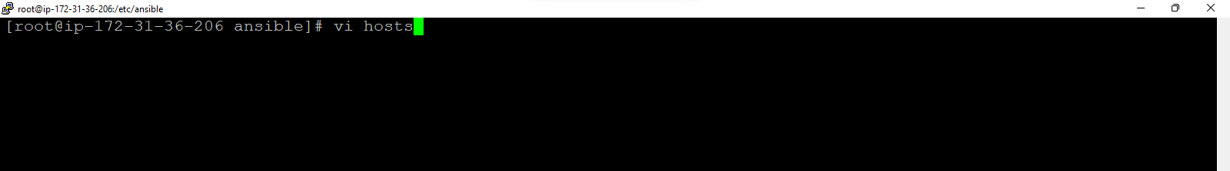

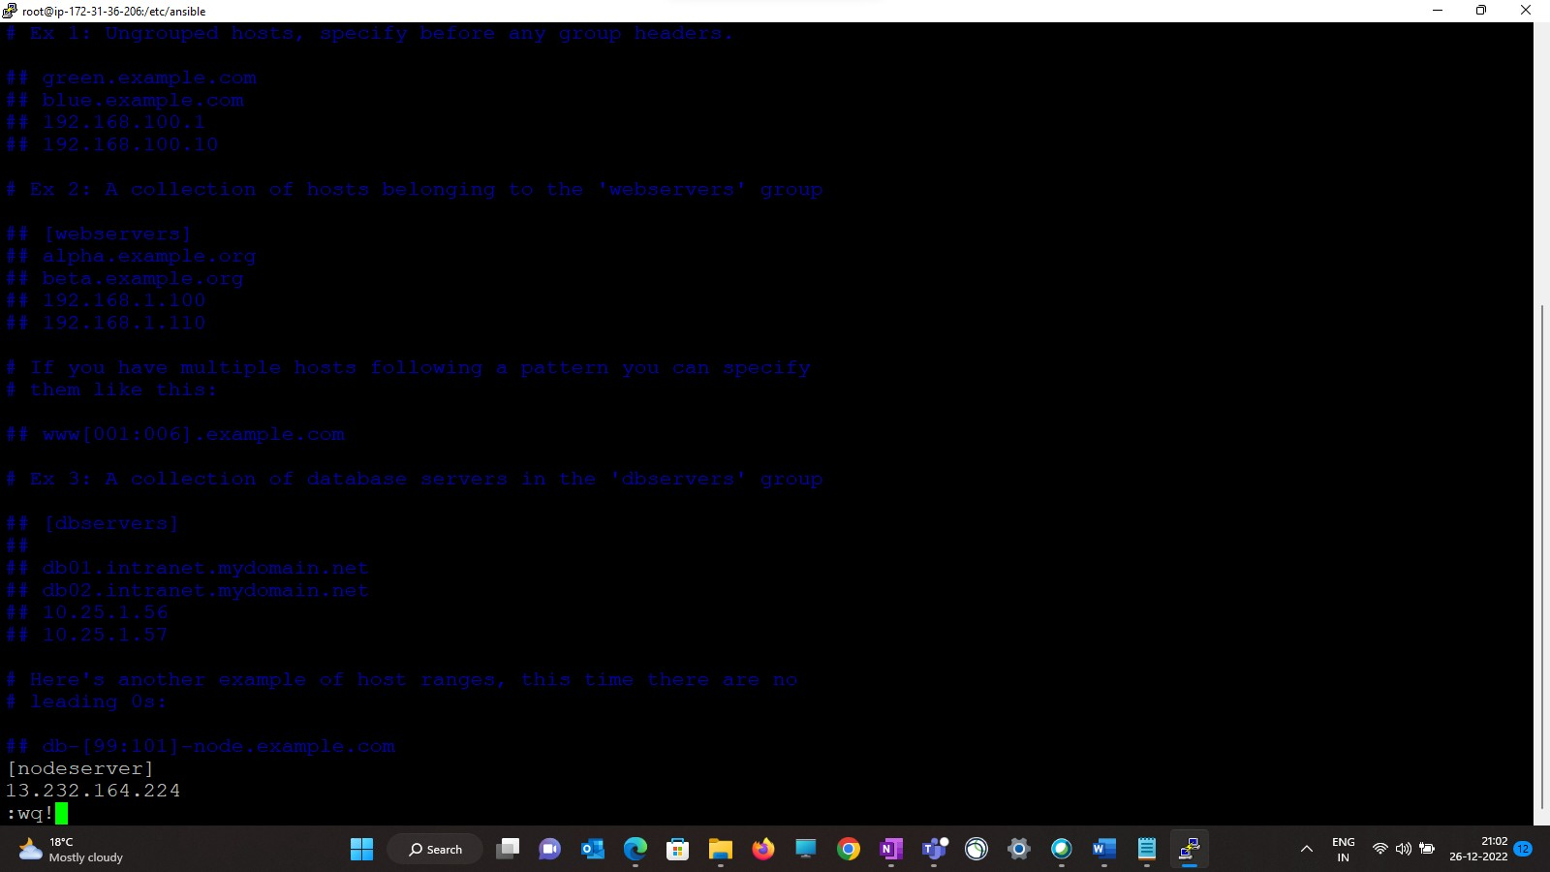

### Now Close Putty and open again

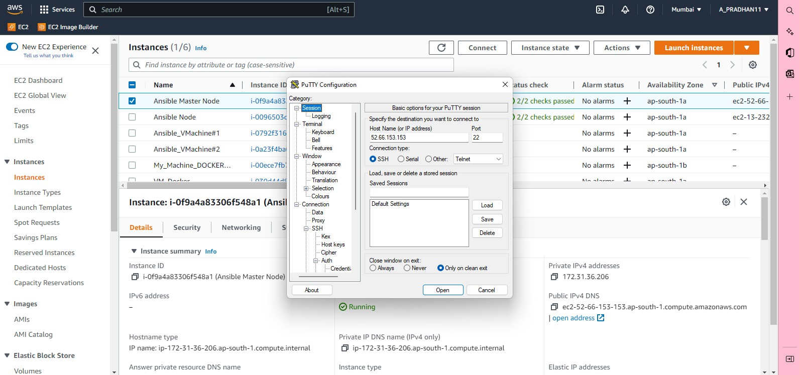

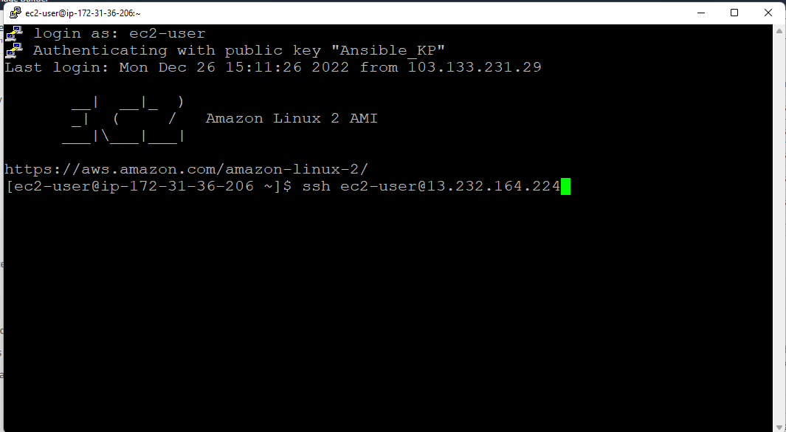

Provide Node ip like : ssh ec2-user@ 13.232.164.224 Then, Master will connected to Node like:

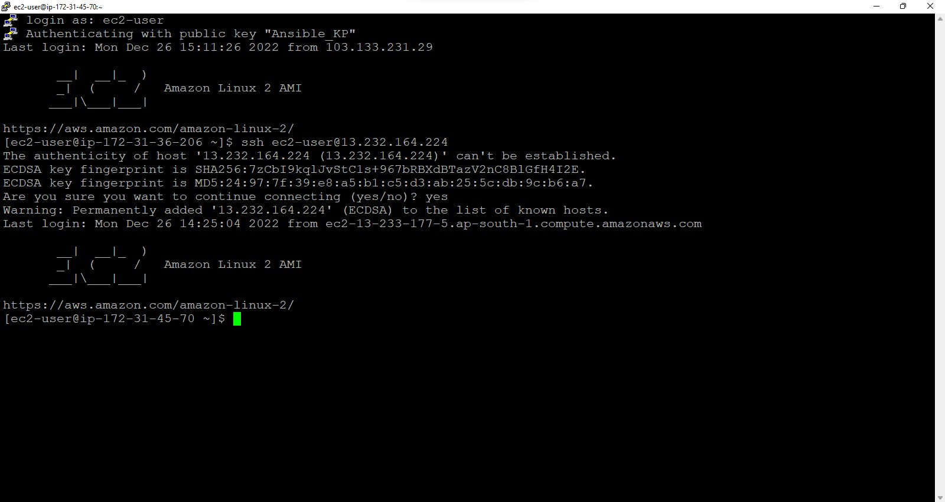

### Now checking authorized keys of Node

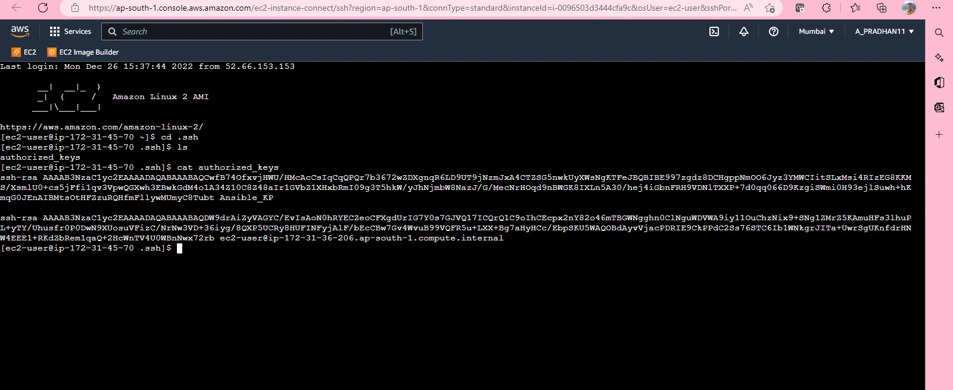

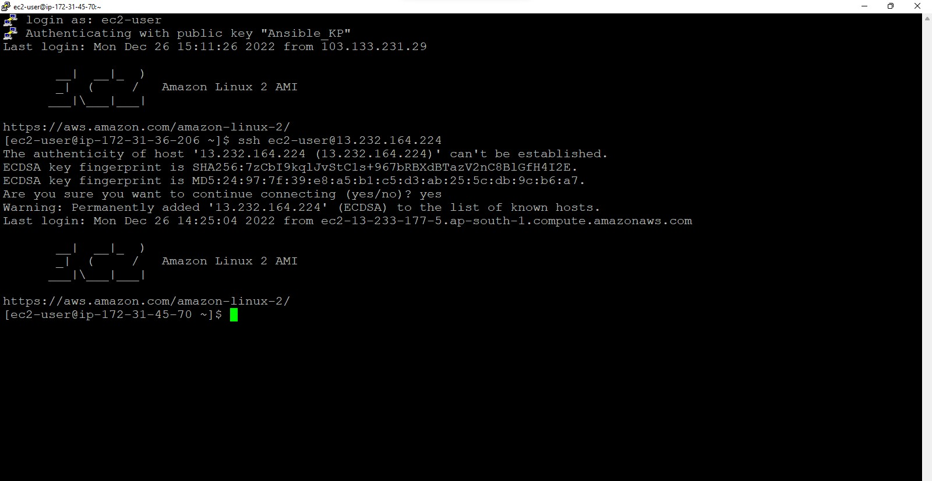

Under Master, Child Node

# Now Some Ad-hoc Commands from the Master

## Again open Putty with master

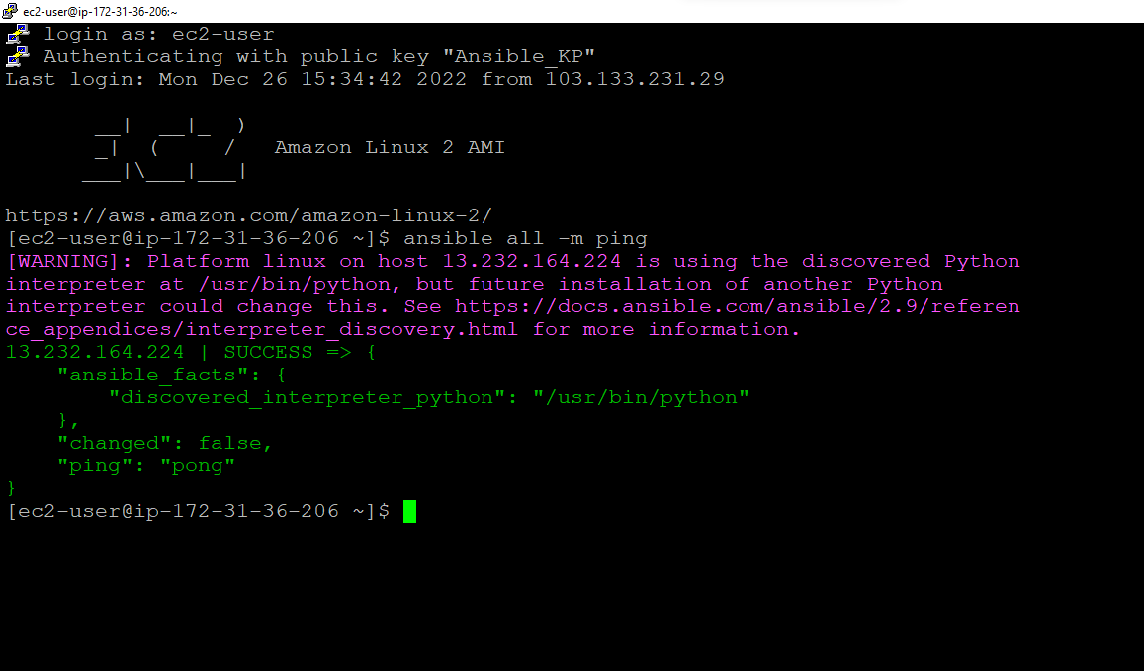

Node ip vm connected successfully

## Now ad-hoc commands

1) ansible all -m yum -b -a “name=git”

# install git on Master

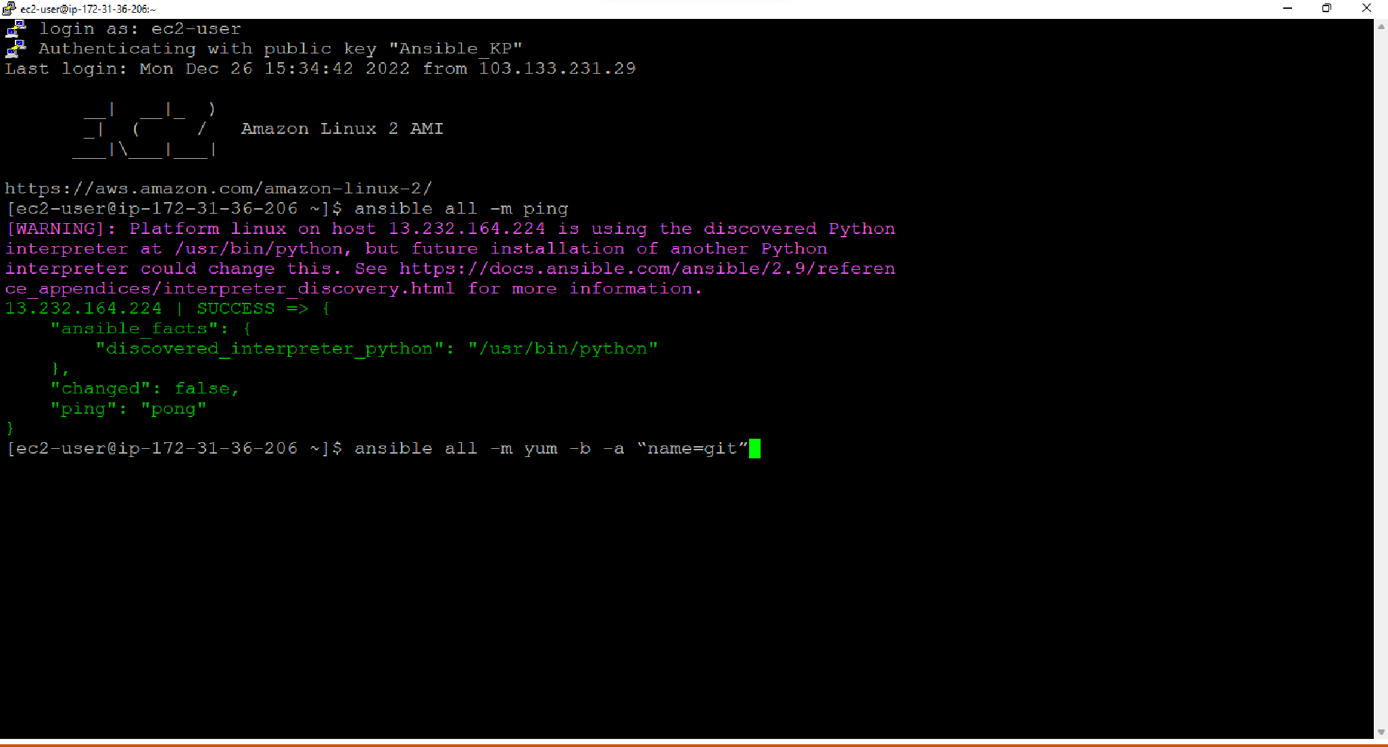

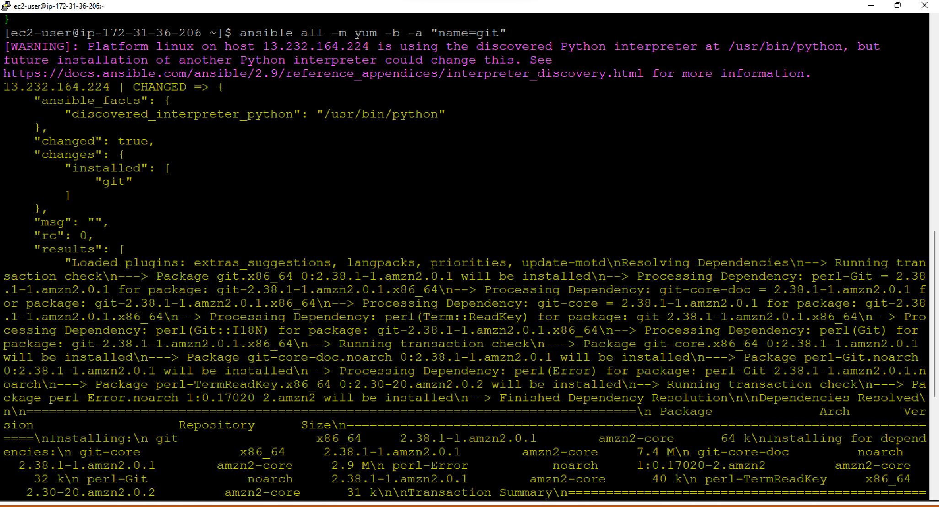

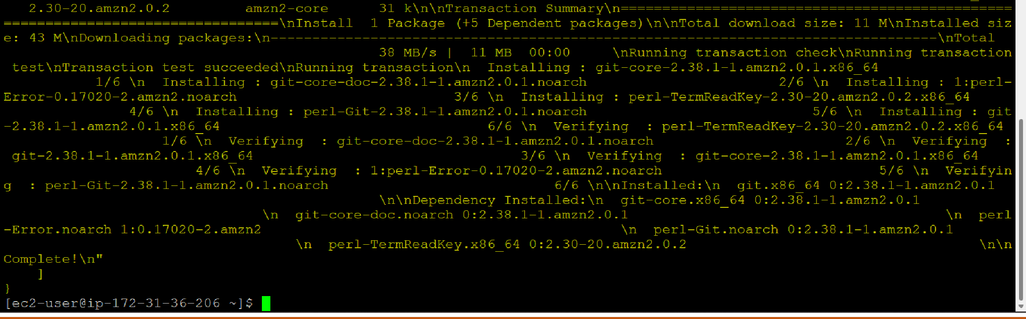

Now Git has installed on Master Then Checking Git on Node:

## Yes, Git available on node also. Now removing git from the Master

Command: ansible all -b -a "yum remove git -y"

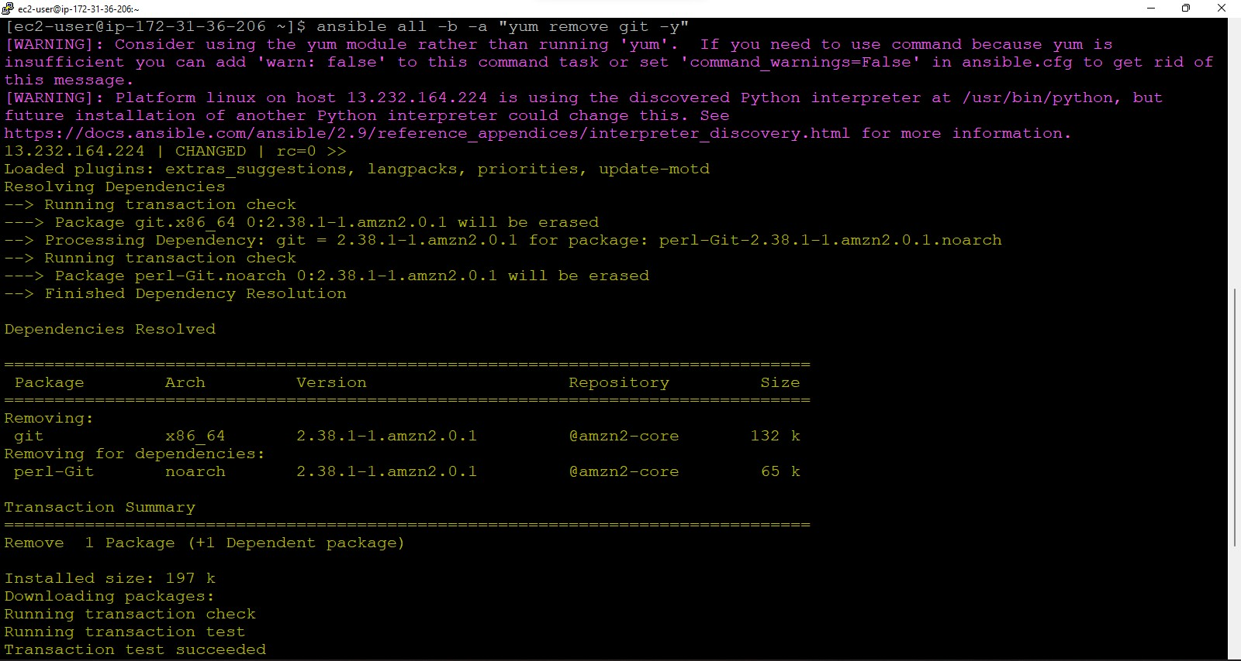

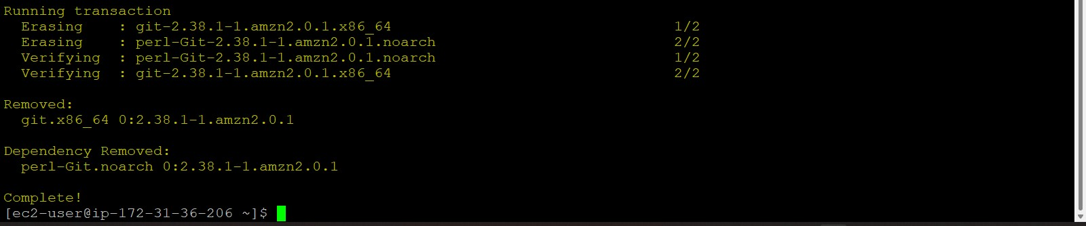

Command: **ansible all -m yum -b -a "name=java"**

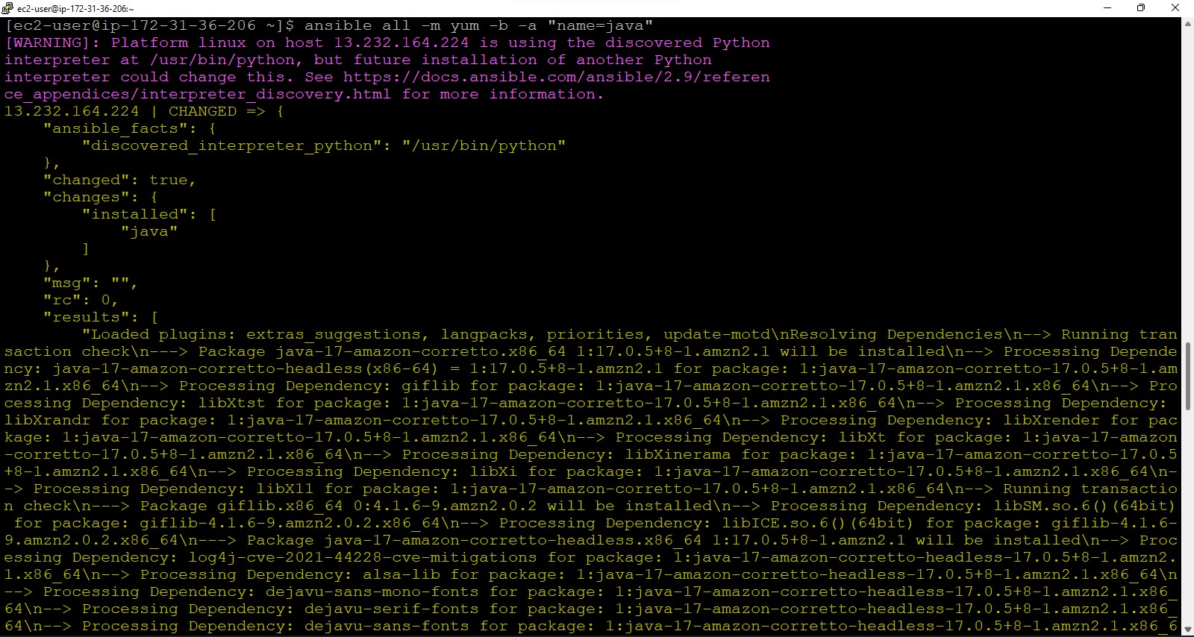

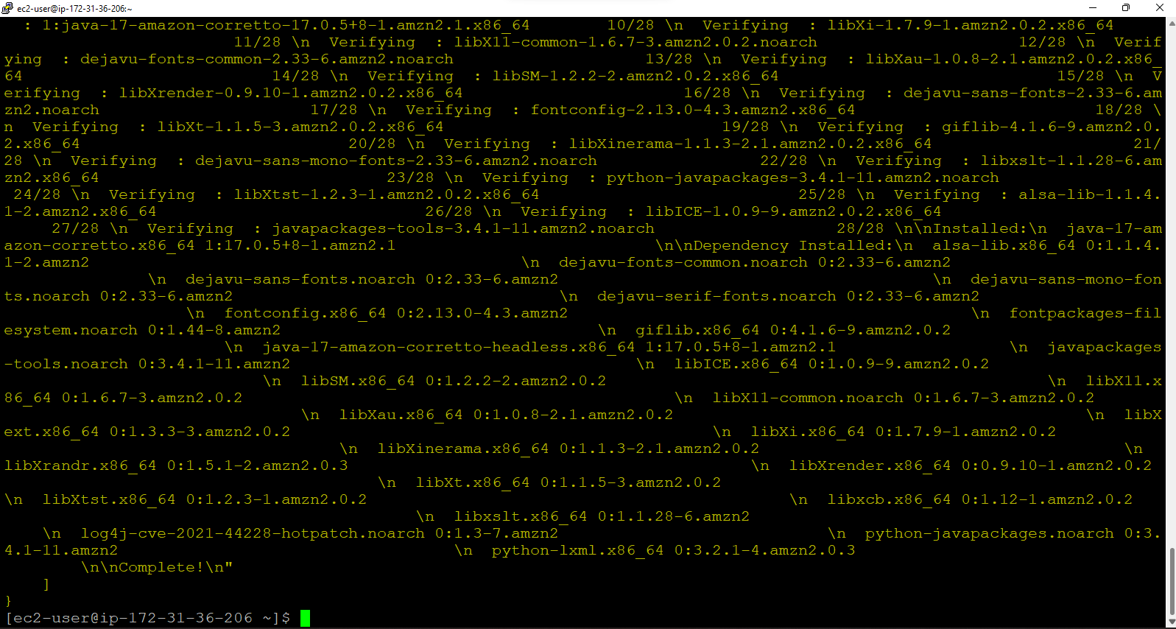

### Java installed on Master.

From Node:

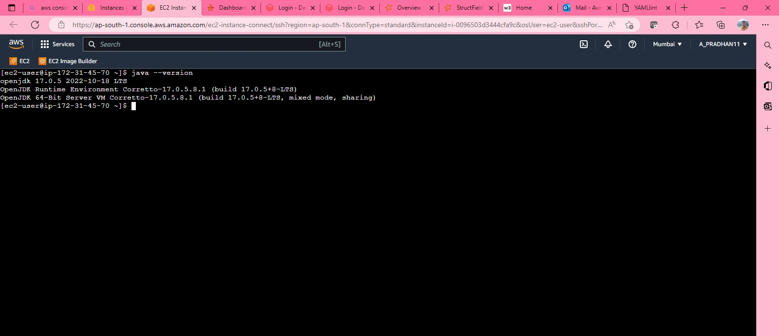

### Now, Java also installed on Node vm.